TABLE OF CONTENTS
ABSTRACT……………………………………………………………………………………2
KEYWORDS…………………………………………………………………………………..2
TABLES AND FIGURES……………………………………………………………………..2
- INTRODUCTION…………………………………………………………………………3
- WHAT WE KNOW ABOUT THE CRISIS? ……………………………………………..3
- MACROECONOMIC POLICIES LESSONS AFTER THE CRISIS…………………….5
  - Macroeconomics : Core and Periphery……………………………………………….5
  - Economic Growth and Development…………………………………………………6
  - Monetary policy………………………………………………………………………7
  - Fiscal policy…………………………………………………………………….…….8

MACROPRUDENTIAL POLICY……………………………………………………….10
4.1. What is Macroprudential Policy? …………………………………………………...10
4.2. Macroprudential Tools………………………………………………………………10

- CONCLUSIONS……………………………………………………………………..….13
- REFERENCES…………………………………………………………………………..14

ABSTRACT
In this paper I define the macroeconomic policies as policies that can be affected by even a little bit financial risk. The 2008-2009 financial crises affect all the economic aggregate variables around the world. But these changes differ from a country to another. I explained how we can rethink about monetary policy and what is the monetary policy strategy that government must choose to prevent financial risks. This crisis has brought a number of weaknesses in macroeconomic policy, financial regulation, and global financial architectures. The new Macroprudencial policy has a lot of important instruments used as financial regulation system. Expansionary fiscal policy in combination with budget deteriorations implied by automatic budget reactions will drive up public debt, which, in turn, may create future adjustment problems.

KEYWORDS
International financial architecture, regulation and supervision, financial crises, subprime lending, contagion, households leverage, Financial risk, Fiscal policy, Macroprudencial Policy, Macroeconomics.
- balance sheet : a written statement showing the amount of money and property that a company has and listing what has been received and paid out;
- Downturn : a fall in the amount of business that is done; a time when the economy becomes weaker
- Oxford Advanced Learner’s Dictionary, 8th edition
- nexus : a complicated series of connections between different things Examples: the nexus between industry and political power
- a nexus of interests

TABLES AND FIGURES
Table 1: The fiscal, primary and revenue deficit, (per cent to GDP)……………………….…..10
Table 2: Macroprudential policy tools………………………………………………………………11
Table 3: Macroprudential instruments………………………………………………………………12
Figure 1: Diagram of the Mechanics of Financial Crises……………………………………...….4
Figure 2: Annual GDP Growth, 2005-2010………………………………………………...…6
Figure 3: World map showing real GDP growth rates for 2009. (Countries in brown were in recession.)…………………………………………………………………………………………………7

- INTRODUCTION
A little more than three years ago, a severe financial crisis engulfed the world economy. A number of major financial institutions failed, world trade collapsed, unemployment soared, and global output registered a dramatic decline. As many governments simultaneously tried to sustain aggregate demand with aggressive expansionary policies, public finances came under acute stress and balance sheets of major central banks ballooned. The world economy has regained some of its footing since then, yet many challenges still remain.
During the current global financial crisis, failures have surfaced in macroeconomic policies and the regulation and supervision of banks and non-banking institutions. It is now clear that agencies involved in regulation, supervision, and crisis management did not always have clear mandates and tools commensurate with these mandates, and that there was a lack of international consistency and coherence of policies. The global financial crisis has also led to a reconsideration of the benefits and costs of open financial markets, leading to calls for a reassessment of the global financial architecture.
This paper draws lessons from the recent financial crisis for macroeconomic policies, reforming financial systems and financial regulation. To properly diagnosis the problem, the paper will replies to the following question: What we know about the crisis; It highlights and the multiple causes. The paper will continues with the lessons from macroeconomic policies after the crisis, by explaining the core and periphery of macroeconomics; changes in Economic Growth, Monetary policy and fiscal Policy. Finally we will explain the Macro prudential policy and it tools.
- WHAT WE KNOW ABOUT THE CRISIS?
The financial crisis of 2007–2008, also known as the global financial crisis and 2008 financial crisis, is considered by many economists to be the worst financial crisis since the Great Depression of the 1930s. It resulted in the threat of total collapse of large financial institutions, the bailout of banks by national governments, and downturns in stock markets around the world. In many areas, the housing market also suffered, resulting in evictions, foreclosures and prolonged unemployment. The crisis played a significant role in the failure of key businesses, declines in consumer wealth estimated in trillions of US dollars, and a downturn in economic activity leading to the 2008–2012 global recession and contributing to the European sovereign-debt crisis. The active phase of the crisis, which manifested as a liquidity crisis, can be dated from August 7, 2007 when BNP Paribas terminated withdrawals from three hedge funds citing "a complete evaporation of liquidity".
The bursting of the U.S. housing bubble, which peaked in 2006, caused the values of securities tied to U.S. real estate pricing to plummet, damaging financial institutions globally. The financial crisis was triggered by a complex interplay of government policies that encouraged home ownership, providing easier access to loans for subprime borrowers, overvaluation of bundled sub-prime mortgages based on the theory that housing prices would continue to escalate, questionable trading practices on behalf of both buyers and sellers, compensation structures that prioritize short-term deal flow over long-term value creation, and a lack of adequate capital holdings from banks and insurance companies to back the financial commitments they were making. Questions regarding bank solvency, declines in credit availability and damaged investor confidence had an impact on global stock markets, where securities suffered large losses during 2008 and early 2009. Economies worldwide slowed during this period, as credit tightened and international trade declined. Governments and central banks responded with unprecedented fiscal stimulus, monetary policy expansion and institutional bailouts. In the U.S., Congress passed the American Recovery and Reinvestment Act of 2009. In the EU, the UK responded with austerity measures of spending cuts and tax increases without export growth and it has since slid into a double-dip recession.
Figure 1: Diagram of the Mechanics of Financial Crises
Many causes for the financial crisis have been suggested, with varying weight assigned by experts. The U.S. Senate's Levin–Coburn Report asserted that the crisis was the result of "high risk, complex financial products; undisclosed conflicts of interest; the failure of regulators, the credit rating agencies, and the market itself to rein in the excesses of Wall Street." The 1999 repeal of the Glass–Steagall Act effectively removed the separation between investment banks and depository banks in the United States. Critics argued that credit rating agencies and investors failed to accurately price the risk involved with mortgage-related financial products, and that governments did not adjust their regulatory practices to address 21st-century financial markets. Research into the causes of the financial crisis has also focused on the role of interest rate spreads.

In the immediate aftermath of the financial crisis palliative fiscal and monetary policies were adopted to lessen the shock to the economy. In July, 2010, the Dodd-Frank regulatory reforms were enacted to lessen the chance of a recurrence.

- MACROECONOMIC POLICIES LESSONS AFTER THE CRISIS
The crisis has shown that macroeconomists and central bankers knew less than what they thought they did. Looking forward, macroeconomic policy framework should be redesigned to implement the lessons from the crisis. These lessons involve the changes in economic growth and development, the objective and nexus of monetary policy and fiscal policy. But before we have to know something about core and Periphery of Macroeconomics.
  - Macroeconomics : Core and Periphery
The ultimate goal of macroeconomics is to explain and model the (simultaneous) aggregate outcomes that arise from the decisions made by multiple and heterogeneous economic agents interacting through complex relationships and markets.
- The periphery of macroeconomics
The insight-building mode (both past and present) of the periphery of macroeconomics has proven to be more useful than the macro-machine-building mode of the core to help our understanding of significant macroeconomic events. For example, in the context of the current financial and economic crisis, the periphery gave us frameworks to understand phenomena such as speculative bubbles, leverage cycles, fire sales, flight to quality, margin- and collateral-constraint spirals, liquidity runs, and so on- phenomena that played a central role in bringing the world economy to the brink of a severe depression. Yet the periphery of macroeconomics is defined not only by its subjects, but also, and perhaps even more so, by a methodological decision which makes its goals narrower than those of the core.
- The Core of macroeconomics
The core approach to macroeconomics, as it is taught in most graduate programs and as it appears in leading journals, begins with a neoclassical growth model. This model is then developed into a stochastic form. The early versions were called “real” business cycles, because the key shocks occurred to technology. After much trial and error, these core models have managed to generate reasonable numbers for quantities during plain-vanilla, second-order business cycle fluctuations.

  - Economic Growth and Development
In terms of impact on GDP and GDP growth, the crisis appears to have affected high- and upper middle-income countries more than poorer countries, even though there may have been greater suffering in lower income countries, as a drop in GDP growth might be more severe in an environment without social safety nets and widespread poverty as a result of the crisis.
Figure 2: Annual GDP Growth, 2005-2010
The change of trend in the GDP growth rate from the average of the years prior to the crisis (2003–2007) to the average of the crisis years 2008–2009. This measure has been chosen because the crisis hit different countries at different points in time. World trade was already severely affected in the last quarter of 2008, and some countries already had trouble financing their foreign deficit that year. However, due to the base effect, this drop is partly reflected in the annual GDP growth rate in 2008 and partly in 2009. Looking only at the growth rate of one of these two years would have distorted the picture. The simple average growth rate of GDP for the years 2008 and 2009. Again, looking at both years together gives a better picture than looking only at 2009 when most of the decline occurred.
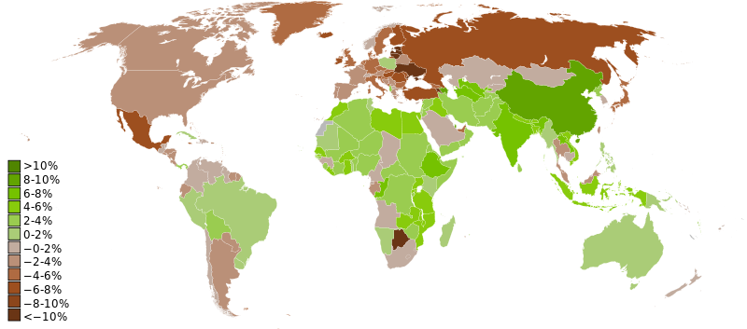
Figure 3: World map showing real GDP growth rates for 2009. (Countries in brown were in recession.)
Source : Wikipedia
  - Monetary policy
The crisis has reopened the debate on what to do regarding asset price booms and increases in leverage. Should monetary policy be concerned with financial markets developments? Should policy be used to dampen booms and prevent build-up of leverage? This seems like the wrong way of approaching the problem. The policy rate is a poor tool to deal with excess leverage, excessive risk taking, or apparent deviations of asset prices from fundamentals. Even if a higher policy rate reduces some excessively high asset price, it is likely to do so at the cost of a larger output gap. Were there no other instrument, the central bank would indeed face a difficult task, and this has led a number of researchers to argue against reacting to perceived asset bubbles and other variables.
The monetary policy strategy that follows from the eight principles of the new neoclassical synthesis is referred to in the academic literature as “flexible inflation targeting” (Svensson, 1997). It involves a strong, credible commitment by the central bank to stabilize inflation in the long run, often at an explicit numerical level, but also allows for the central bank to pursue policies to stabilize output around its natural rate level in the short run.
The global financial crisis of 2007-2009 was not only a tsunami that flattened the economy, but in the eyes of some commentators it has flattened the science of monetary policy, requiring a total rethink.There are five lessons that should change how we think about the science of monetary policy and monetary policy strategy.
- Developments in the financial sector have a far greater impact on economic activity than we earlier realized.
The global financial crisis of 2007-2009 therefore demonstrated that financial frictions should be front and center in macroeconomic analysis: they no longer could be ignored in the macro-econometric that models that central banks use for forecasting and policy analysis, as we saw was the case before the crisis. As a result, there is a resurgence of interest in the interaction of finance and macroeconomics. Economists, both in academia and in central banks, are now actively trying to build financial frictions into their general equilibrium models, and there is a new literature that is in its infancy to explore how financial frictions would modify the prescriptions provided by the science of monetary policy.

- The macro economy is highly nonlinear.
The role of nonlinearities in the macro economy when there is a financial disruption implies an important flaw in the theory of optimal monetary policy that was in general use prior to the crisis: the theory of optimal monetary policy was based on the assumption that the macro economy can be described by linear dynamic equations. The financial crisis of 2007-2009 demonstrates that although the linear-quadratic framework may provide a reasonable approximation to how optimal monetary policy operates under fairly normal circumstances, this approach will not be adequate for thinking about monetary policy when financial disruptions hit the economy.

- The zero lower bound is more problematic than we realized.
The zero-lower-bound problem is more serious than previously thought because contractionary shocks to the economy can be far greater than was previously anticipated. Sufficiently large contractionary shocks can make the magnitude of the costs of the zero-lower-bound constraint very large. Large contractionary shocks can thus overwhelm the ability of conventional policy to counteract them, and may require massive interventions in credit markets and central bank expansion of their balance sheets.

- The cost of cleaning up after financial crises is very high.
- Price and output stability do not ensure financial stability.
Inflation, even core inflation, may be stable, and the output gap may nevertheless vary, leading to an obvious trade-off between the two. (This is hard to prove empirically, as the output gap is not directly observable. What is clear, however, is that the behavior of inflation is much more complex than is assumed in our simple models and that we understand the relationship between activity and inflation quite poorly, especially at low rates of inflation.) Or, as in the case of the pre-crisis 2000s, both inflation and the output gap may be stable, but the behavior of some asset prices and credit aggregates, or the composition of output, may be undesirable (e.g., too high a level of housing investment, too high a level of consumption, or too large a current account deficit) and potentially trigger major macroeconomic adjustments later on.
  - Fiscal policy

The need and scope for discretionary fiscal policy depend on the nature of the shock and on the value added it may contribute to monetary policy responses and automatic budget reactions. In the following, these issues are briefly considered.
While the origin of the crisis is attributed to the financial sectors, there are also some real counterparts. Most notably, the fact that the housing markets in a number of countries have been overheated is reflected both in excessive house price increases and a booming activity level in the sector. The specific problems in the financial sector (liquidity and solvency issues) are not to be discussed here, but the financial sector itself has also been overheated. Moreover, the implied effects for credit policy (eventually a credit crunch) are important since they make borrowing constraints more binding. This, in turn, has implications for both investments and consumption.
A key lesson from the crisis is the desirability of “fiscal space” to run larger fiscal deficits when needed. Going forward, the required degree of adjustment after the recovery is securely under way will be formidable, in light of the need to reduce debts against the background of aging-related challenges in pensions and health care. More generally, the lesson from the crisis is clearly that target debt levels may need to be lower, or at least the fiscal spaces need to be higher, than those observed before the crisis. The policy implication for the next decade is that, should economic growth recover rapidly, this should be taken as an opportunity to reduce debt/GDP ratios substantially, rather than to finance expenditures increases or tax cuts.
The exception of this crisis confirms the problems with discretionary fiscal measures: They come in too late to fight a standard recession. There is, thus, a strong case for improving the automatic stabilizers. One must distinguish here between truly automatic stabilizers—i.e., those which by their very nature imply a pro-cyclical decrease in transfers or increase in tax revenues and rules that allow some transfers or taxes to vary conditional on pre-specified triggers based on the state of the economic cycle.
The first type of automatic stabilizers comes from the combination of rigid government expenditures with an approximately unit elasticity of revenues with respect to output, from the existence of social insurance programs (defined-benefit pension systems fall into this category), and from the progressive nature of income taxes. The main ways to increase their macroeconomic effect would be to increase the size of government or (to a lesser extent) to make taxes more progressive or to make social insurance programs more generous. Reforms along these lines justified or not, should not be motivated by the desire to stabilize the economy.
The second type of automatic stabilizers appears more promising. They do not carry the costs mentioned above and can be applied to tax or expenditure items with large multipliers. On the tax side, one can think of temporary tax policies targeted at low-income households, such as a flat, refundable tax rebate, a percentage reduction in a taxpayer’s liability, or tax policies affecting firms, such as cyclical investment tax credits. On the expenditure side, one can think of temporary transfers targeted at low-income or liquidity-constrained households. These taxes or transfers would presumably be triggered by the crossing of a threshold by a macro variable. The variable which comes most naturally and could work best, GDP, is only available with a delay. The next logical choices are labor market variables, such as employment or unemployment. How to define the relevant threshold, what taxes or transfers to make contingent, are issues that must be worked on.
Table 1: The fiscal, primary and revenue deficit, (per cent to GDP)
MACROPRUDENTIAL POLICY
4.1. What is Macro prudential Policy?
The term “macroprudential” has become a true buzzword, yet it was little used before the crisis and its meaning remains elusive. The term “macroprudential” has risen from virtual obscurity to extraordinary prominence following the recent financial crisis. In this narrower sense, closer to its origin, the term refers to the use and calibration of prudential tools with the explicit objective of promoting the stability of the financial system as a whole, not just the individual institutions within it.
4.2. Macro prudential Policy Tools
Financial regulation, should address three key sources of instability: defaults, credit crunches, and firesales. Firesales were a critical factor in the recent crisis. Especially for emerging market economies, the macroprudential toolkit could also include measures to limit system-wide currency mismatches, which aim at stemming the domestic financial consequences of capital inflows. e.g. Countercyclical, capital charges. It is important to understand precisely how different instruments operate on different margins, with potentially diverse general equilibrium effects. For instance, liquidity requirements can be imposed on the asset side of banks’ balance sheets (increasing the amount of cash resources relative to loans) or on the liability side (limiting the reliance of short-term funding).
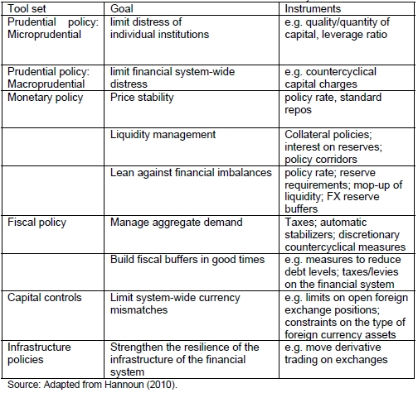

Table 2: Macroprudential policy tools
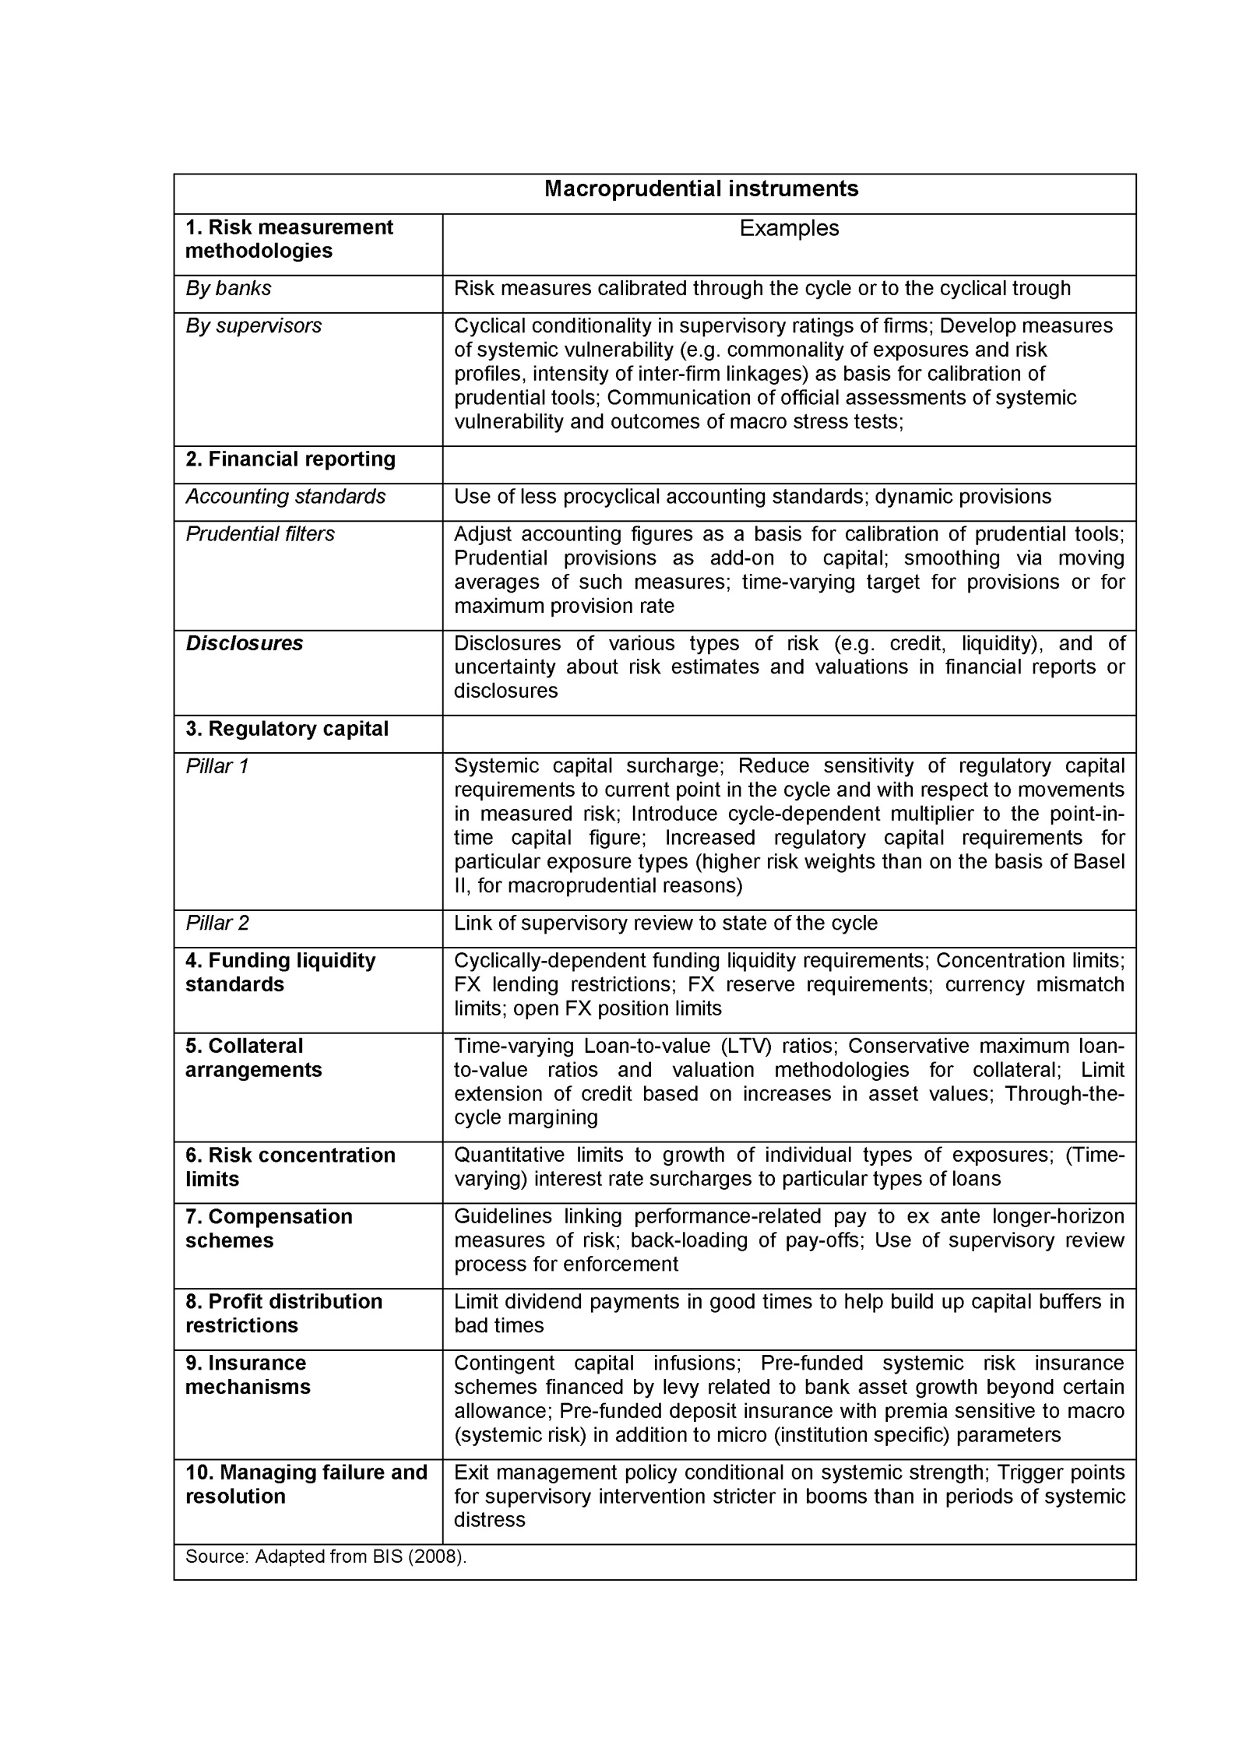

Table 3: Macroprudential instruments

- CONCLUSIONS
The current crisis represents the most significant set of economic events internationally since the decade spanning the mid-1970s and the mid-1980s. The economic order created following that turbulent decade is now breaking down. What replaces it will depend not just on `objective’ circumstances but on the ability of the left to put forward its own vision of an economy based on need rather than profit as a replacement for the finance-driven accumulation of the last twenty years.
The financial crisis has brought a number of weaknesses in macroeconomic policy, financial regulation, and global financial architectures into the open. These include the treatment of systemically important financial institutions; the assessments of systemic risks and vulnerabilities; and the resolution of financial institutions. The recent financial crisis, however, does require some major rethinking about the details of this basic framework for monetary policy strategy.
The crisis was not primarily triggered by macroeconomic policy. But it has exposed flaws in policy pre-crisis, forced policy makers to explore new policies during the crisis, and forces us to think about the architecture of macroeconomic policy post-crisis. In many ways, the general frame of policy should remain the same. The ultimate goals should be to achieve a stable output gap and stable inflation. But the crisis has made clear that policy makers have to watch many targets, including the composition of output, the behavior of asset prices, and the leverage of different agents. It has also made clear that they have potentially many more instruments at their disposal than they had used pre-crisis. The challenge is to learn how to use these instruments in the best way. The combination of traditional monetary policy and regulation tools, and the design of better automatic stabilizers for fiscal policy, are two promising routes.
The reform agenda is enormous, much remains to be done, and new questions have come up for the design of more stable national and global financial systems. The global nature of the financial crisis has made clear that financially integrated markets, while offering benefits in the long run, pose significant short-term risks, with large real economic consequences, and that reforms are needed to the international financial architecture to safeguard the stability of an increasingly integrated global financial system. Such reforms need to be guided by the right principles rather than being formulated as rushed responses to the public pressure. In particular, the reforms should rely on economic reasoning to identify the market failures and the externalities as well as to device the best way to solve the incentive problems.

- REFERENCES
Frederic S. Mishkin Working Paper 16755: MONETARY POLICY STRATEGY: LESSONS FROM THE CRISIS http://www.nber.org/papers/w16755.
Keynote speech by Jaime Caruana, General Manager, Bank for International Settlements Macroprudential policy: what we have learned and where we are going;
PIERRE-OLIVIER GOURINCHAS and M. AYHAN KOSE IMF Economic Review (2011): Macroeconomic and Financial Policies after the Crisis 59, 137–144. doi:10.1057/imfer.2011.11
Ricardo J. Caballero Working Paper 16429: MACROECONOMICS AFTER THE CRISIS: TIME TO DEAL WITH THE PRETENSE-OF-KNOWLEDGE SYNDROME
Stijn Claessens, Giovanni Dell’Ariccia, Deniz Igan, and Luc Laeven IMF working Paper; Lessons and Policy Implications from the Global Financial Crisis
Torben M. Andersen Economics Working Paper 2009 School of Economics and Management Aarhus University: Fiscal policy and the global
financial crisis,
Wikipedia The financial crisis of 2007–2008; link: http://en.wikipedia.org/wiki/Financial_crisis_of_2007%E2%80%932008

