T.C

AKDENIZ UNIVERSITY
Faculty of Economics and Administrative Sciences
DEPARTEMENT OF ECONOMY

Seminar
Topics:

International Trade: Case of Niger

ANTALYA 2014

By
Mahamane Moutari Abdou
Students ID: 20100401110

Supervisor: Associate Prof. Ayşegül ATEŞ

TABLE OF CONTENTS
Pages
LIST OF TABLES .............................................................................3
LIST OF FIGURES............................................................................3
ACRONYMS AND ABBREVIATIONS ..........................................3
ABSTRACT.........................................................................................6
- INTRODUCTION......................................................................6
- BRIEF OVERVIEW OF NIGER’S ECONOMY...................6
- FOREIGN TRADE OF NIGER...............................................
  - Overview of Niger Foreign Trade.................................................
    - Exports................................................................................................
    - Imports................................................................................................
  - Analysis of Balance of Payments.................................................
- REGIONAL AND BILATERAL RELATIONS....................
  - The position of Niger’s Foreign Trade in Africa........................
  - The position of Niger’s Foreign Trade in the World...................
  - The Relationship between Niger and Regional and International (Trade) Organizations.................................................................
  - Agreements With Regional and International (trade) Organizations..............................................................................
- CONCLUSION.......................................................................
- REFERENCES.........................................................................

LIST OF TABLES
Table 1: Evolution of Foreign Trade 1973-2012
Table 2: Exports by Products
Table 3: Exports Structure by products 2008-2012
Table 4: Exports Structure by products (In percents) 2008-2012
Table 5: Exports by main destination countries
Table 6: Imports by main Countries of Origin
Table 7: Evolution of the global balance of the balance of payments (Amounts in millions of FCFA)
Table 8: Current Account (percentage of GDP)
Table 9: Evolution of the balance of payments (optical BCEAO)
LIST OF FIGURES
Figure 1: Mine in Arlit (Agadez)...........................................................................................6
Figure 2: Economic map of Niger (1969
Figure 3: Niger’s Real GDP growth 2013 (West Africa and whole Africa)
Figure 4: Evolution of Niger Exports 2008-2012
Figure 5: Principal Exportation Products in the First trimester 2013
Figure 6: Evolutions of Exports by Products 20008-2012
Figure 7: Exports Map of Niger
Figure 8: Evolution of imports of Niger during the period 2008 - 2012.
Figure 10: Comparative evolution of the trade balance and current account between 1992 and 2009
ACRONYMS AND ABBREVIATIONS
ACP: African, Caribbean and Pacific (Group of States)
ANIPEX: Association Nigérienne de Promotion des Exportations (Nigerien Association of Export Promotion)
BCEAO: Banque (Central Bank of the West African States)
CCIAN: Chambre de Commerce, d'Industrie et d’Artisanat du Niger (Chamber of Commerce, Industry and Crafts of Niger)
CEDEAO: Communauté économique des États de l'Afrique de l'Ouest (see ECOWAS for English)

CEMAC: Communauté Économique et Monétaire de l'Afrique Centrale (Economic and Monetary Community of Central Africa)
CET: Common External Tariff
CFA franc or FCFA: Communauté Financière Africaine (African Financial Community)
CIF: Cost Insurance Freight
CIRDI: Centre International pour le Règlement des Différends relatifs aux Investissements
ECOWAS: Economic Community of West African States
EPAs: Economic Partnership Agreements
EU: European Union
FOB: Free On Board
GATT: General Agreement on Tariffs and Trade
GDP: Gross Domestic Product
HIPC: Highly Indebted Poor Countries
ICSID: International Centre for Settlement of Investment Disputes
IMF: International Monetary Fund
INS: Institut National de la Statistique (National Institute of Statistics)
LDCs: Least Developed Countries
MFN: Most Favoured Nation
MIGA: Multilateral Investment Guarantee Agency
PCC: Politique Commerciale Commune (Common Commercial Policy)
PRGF: Poverty Reduction and Growth Facility
STABEX: Système de Stabilisation des Recettes d'Exportation (Stabilizing System of Receipts Export)
UEMOA: Union économique et monétaire ouest-africaine (see WAEMU for English)
WAEMU: West African Economic and Monetary Union
WTO: World Trade Organization

ABSTRACT
Trade between countries is one of the key of the world Economy. For satisfy the economic needs of its population each country must insure the production, the distribution or else the importation and exportation of goods and services within this country. This article will show us how Niger insures the importation and exportation of goods and services by trading with other countries. Here the important is to know: What are the elements constituting the International Trade of Niger? And what is the result of regional and bilateral relations of Niger’s Foreign Trade.
- INTRODUCTION
International trade is the exchange of capital, goods, and services across international borders or territories. International trade is also a branch of economics, which, together with international finance, forms the larger branch of international economics. By analyzing each word of this definition, we will determine the characteristics of foreign trade of Niger. We will also combine our researches and the notions that we know about Niger’s international Trade to present the effects, experiences and perspectives that Niger get from its trade relationships with other countries.
In other words, throughout this work we will explain the situation of Niger’s Foreign Trade, the impact of political and social changes on the trade, the regional and international trade relationships and the perspectives on the eventual situations.
- BRIEF OVERVIEW OF NIGER’S ECONOMY
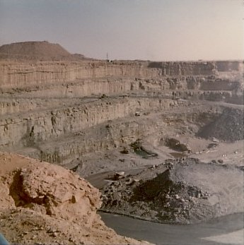
Niger is a landlocked, Sub-Saharan nation, whose economy centers on subsistence crops, livestock, and some of the world's largest uranium deposits. Agriculture contributes about 40% of GDP and provides livelihood for about 90% of the population. Niger also has sizable reserves of oil, and oil production, refining, and exports are expected to grow significantly between 2011 and 2016. Drought, desertification, and strong population growth have undercut the economy. Niger shares a common currency, the CFA franc, and a common central bank, the Central Bank of West African States (BCEAO), with seven other members of the West African Monetary Union.

Figure 1: Mine in Arlit (Agadez)
Source: Wikipedia, Economy of Niger

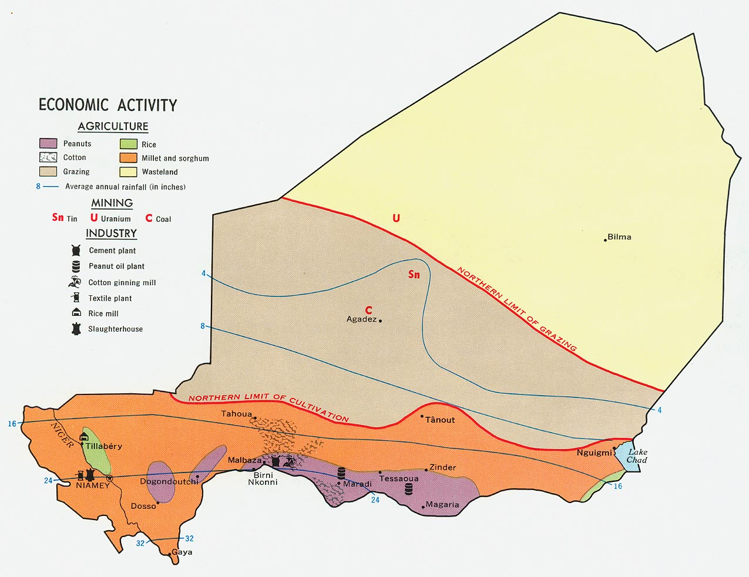
In December 2000, Niger qualified for enhanced debt relief under the International Monetary Fund program for Highly Indebted Poor Countries (HIPC) and concluded an agreement with the Fund on a Poverty Reduction and Growth Facility (PRGF). Debt relief provided under the enhanced HIPC initiative significantly reduced Niger's annual debt service obligations, freeing funds for expenditures on basic health care, primary education, HIV/AIDS prevention, rural infrastructure, and other programs geared at poverty reduction.
Figure 2: Economic map of Niger (1969). Peanut cultivation areas in purple, Rice in green, the remainder of agricultural land in orange. The northern limit of seasonal livestock forage is in brown.
Source: Wikipedia: Economy of Niger
In December 2005, Niger received 100% multilateral debt relief from the IMF, which translated into the forgiveness of approximately US$86 million in debts to the IMF, excluding the remaining assistance under HIPC. The economy was hurt when the international community cut off non-humanitarian aid in response to TANDJA's moves to extend his term as president. Nearly half of the government's budget is derived from foreign donor resources. Future growth may be sustained by exploitation of oil, gold, coal, and other mineral resources. The government, however, has made efforts to secure a new three-year extended credit facility with the IMF following the one that completed in 2011. Oil revenue to the government has fallen well short of its budgeted level. Strikes risk undermining political stability. Food security remains a problem in Niger and is exacerbated by refugees from Mali.
Figure 3: Niger’s Real GDP growth 2013 (West Africa and whole Africa)
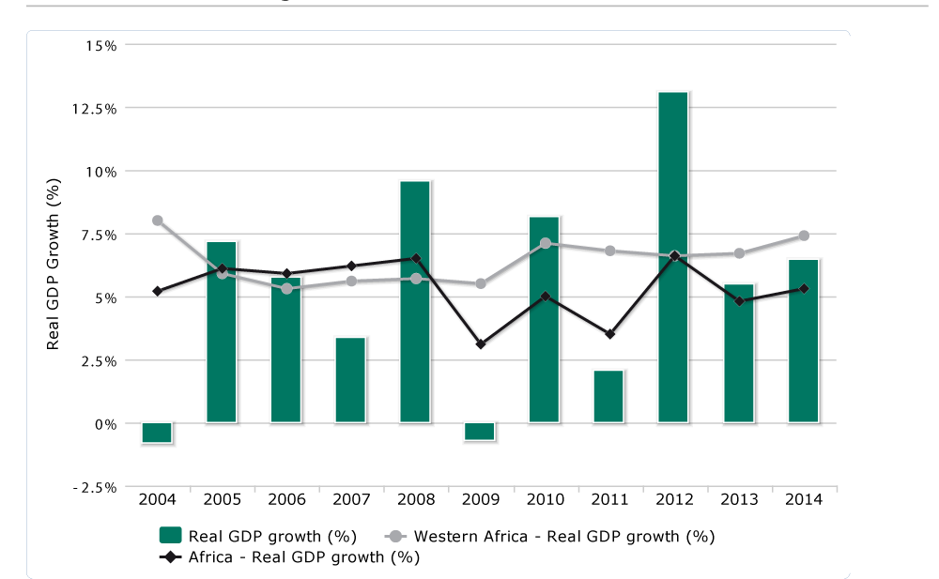
Source: African Economic Outlook
In 2012, Mahamadou ISSOUFOU’s government set a program named 3N (Nigeriens Nourish Nigeriens) which provides domestic productions, consumption and investments. This government is leading a politic of foreign capital flows and innovative investments.
In 2012, GDP grew by an estimated 13.1% in real terms, one of the highest levels recorded in Africa. Growth was boosted by a good harvest and an exceptionally dynamic secondary sector, which grew by almost 38%, driven by the extractive industries. Although there are some risks, the outlook for 2013 and for the medium term is good, with growth expected to average 5.5%. Reducing the national debt remains a challenge. In the political sphere, state institutions were consolidated in 2012. In social affairs, progress was made in human development, but remains slow. Niger is unlikely to achieve all the Millennium Development Goals (MDGs) by 2015.
Huge investment in the oil and mining sectors are encouraging signs for the country’s development. Nevertheless, better policies on the management of natural resources are needed, taking into account environmental externalities. To achieve sustainable mitigation of the economy’s and the population’s recurrent vulnerability to climatic impacts, Niger would benefit from making good use of its mining and oil resources to finance structural investments. Economic diversification is also necessary to generate inclusive growth.
Statistics of Niger’s Economy
Population: 17 129 076 (2012 census)
GDP: Purchasing power parity: $13.34 billion (2012 est.)
Official exchange rate: $6.76 billion (2012 INS data)
GDP - real growth rate: 11.2% (2012 est.); 2.2% (2011 est.); 10.7% (2010 est.)
GDP per capita: $800 (2012 est.)
Inflation rate (consumer prices): 0.5% (2012 est.); 2.9% (2011 est.)
Investment Rate: 34%
Current Account balance: -$1.628 billion (2012 est.); -$1.697 billion (2011 est.)
Source: INS
- FOREIGN TRADE OF NIGER
  - Overview of Niger Foreign Trade
A country’s Foreign Trade is characterized by importation and exportations of goods and services. With 68.4% in 2012, the rate of import coverage by exports is at the highest level of the decade. It gains 18.7 percentage points relative to its level of 2011 (49.7%). The opening rate of the economy, measured by the value of trade relative to GDP, came in at 38.9% in 2012 against 42.0% in 2011. On the whole, foreign trade (exports and imports combined) increased by 4.3% (+54.7 billion) and are to 1,333.7 billion CFA francs in 2012 against 1,279.0 billion in 2011. The deficit in the trade balance is observed with all continents except Europe, particularly with Asia and America with respectively 124.2% and 19.4% of the total deficit.
The Niger foreign trade is generally characterized by a deficit on the balance of payments (see table 1).
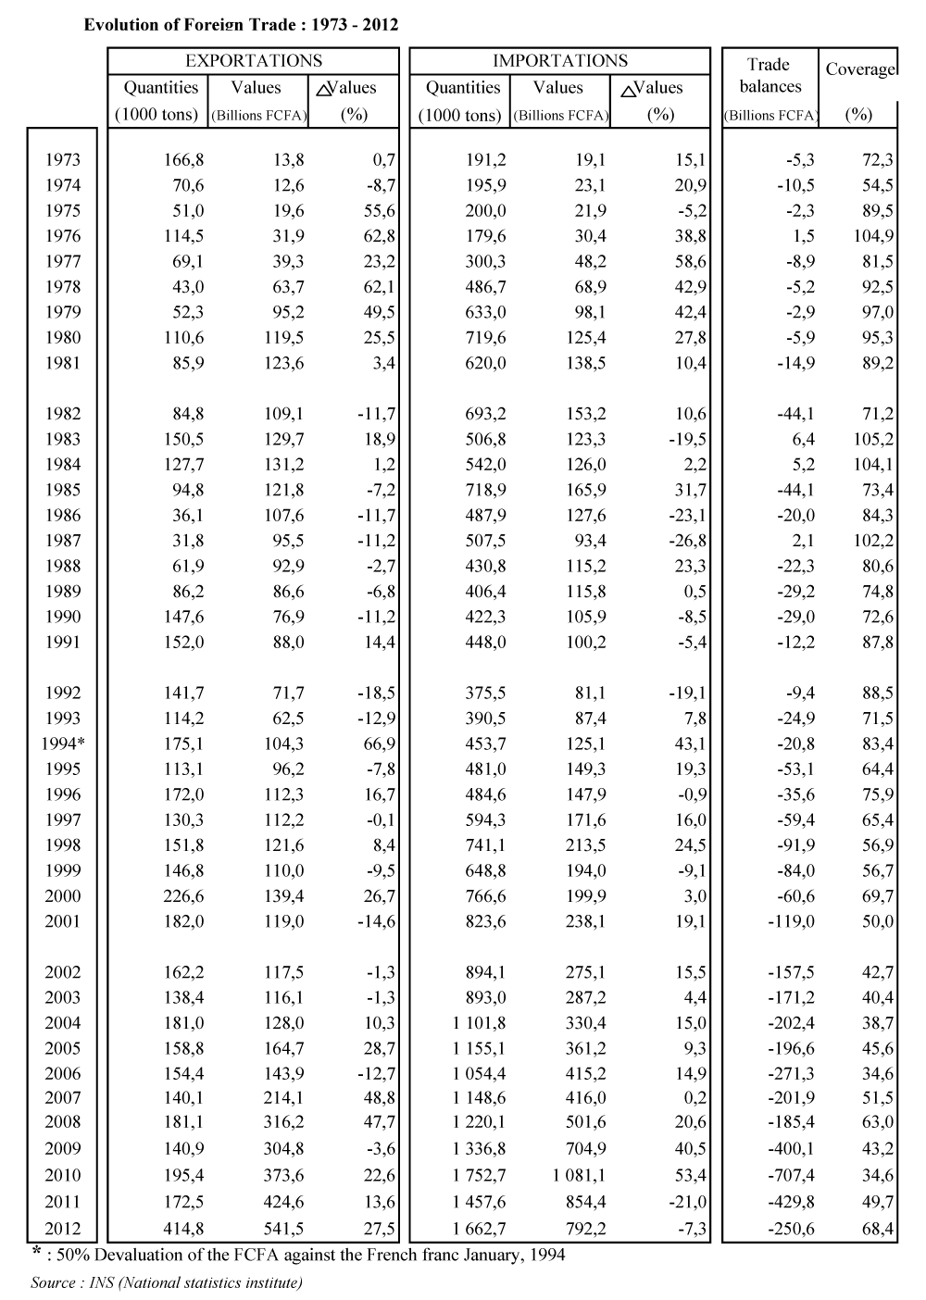
Table 1:
NB: The virgule (,) is the decimal separator for this table.

    - Exports

- Evolution of exports
With 541.5 billion FCFA in 2012 against 424.6 billion FCFA in 2011, there is increase of 117 billion FCFA (27.5%) in the exports. This rising is essentially induced by oil (+108.8) whose exportation is substantially started in 2012.
The exportations passed from 169.3 in the 4th trimester of 2012 to 142.7 in the first trimester of 2013 leading a decrease of 15.7% in the total exportation. This decreasing due to the falling of Uranium production (-37.2 billions) and mitigated by the rising of oil exportations (+37.2 billions), is related to technical problems in the production plant. We can see that any change in the mining productions affect seriously the exportation. Because uranium, which Niger has exported for several decades, remains the country’s leading export product (as we showed in the table 2 and 3 and in graph 3).

Figure 4: Evolution of Niger Exports 2008-2012
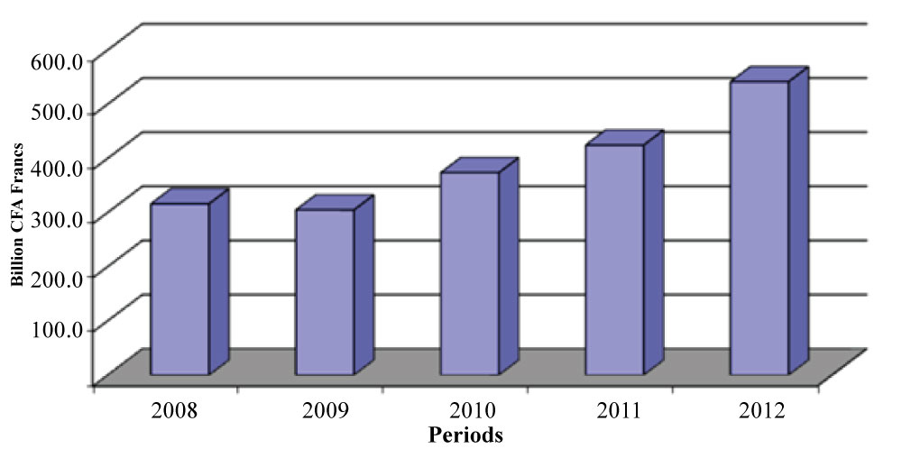
Source: INS (National Statistics Institute) of Niger

- Structure of exports by product: predominance of uranium
Exports in Niger are dominated by uranium products, and agricultural and pastoral products. These are dependent on the fluctuations in world prices and in rainfall. In addition to these main export products, the industrial production of gold, which began in 2005, will henceforth be featured as exports, which started at the beginning of 2006. In the first trimester of 2013 also, the Hydrocarbons (oil) remains the second principal export product with 40.9 billion FCFA against 27.7 billion FCFA in 2012. This increase is due to the exploitation of oil in the Agadem basin started in 2011 by China National Petroleum Corporation (state-owned by the People's Republic of China).

Table 2: Exports by Products
Uranium | Hydrocarbons | Gold | Other Products | Agricultural Products | Pastoral Products
83 540 | 40 934 | 10 275 | 3 258 | 2 650 | 1 996
58,6% | 28.7% | 7.2% | 2.3% | 1.9% | 1.4%
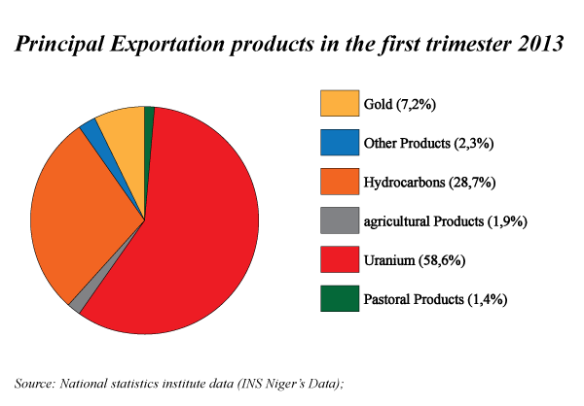
Source: INS (National Statistics Institute) of Niger Unit: in million FCFA
Figure 5:

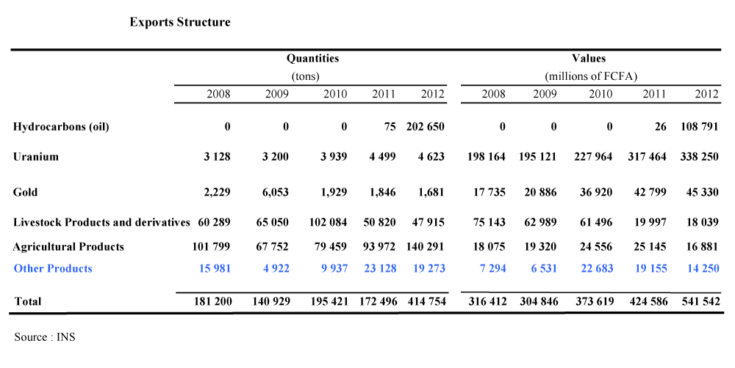
Table 3: Exports Structure by products (values and Quantities) 2008-2012

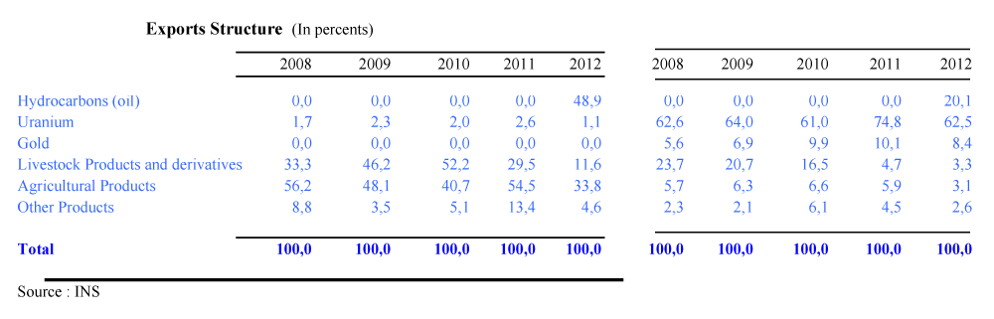
Table 4: Exports Structure by products (In percents) 2008-2012

NB: The virgule (,) is the decimal separator for this table.

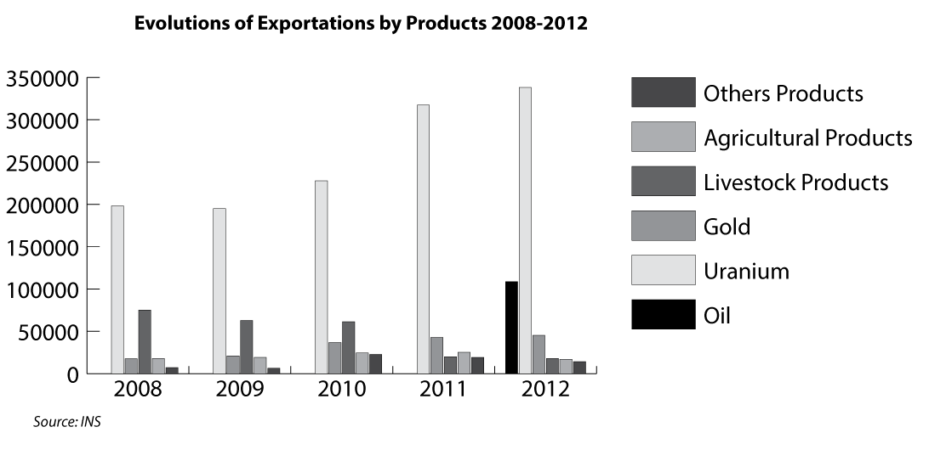
Figure 6:

- Geographical orientation of exports
Talking about the exports partners of Niger, according to the 2013 INS statistic report, we can say that today the five (5) principal partners of Niger are France (55.4 billions: 38.8%), Nigeria (23 billions: 16.2%), United States (28.5 billions: 20.0%), Swiss (10.4 billions: 7.3%), Burkina Faso (22.7 billions: 15.9%). They represent 98.5% of the total value of exportations.
Year over year, the top 5 export destinations of Niger are France with 49.7%, Switzerland 12.6%, Spain 12.4%, Nigeria 9.9% and 4.7% Mali. These countries were the top 5 customers of Niger and hosted 89.3% of export value.
The orientation of exports by continent shows a strong geographic concentration in the 1st quarter 2013. Indeed, Europe, the main continent of destination of exports by value, with 66.3 billion, welcomes 46.5% of total export value. With Africa (47.3 billion or 33.1%), these two (2) continents have received 79.6% of export value. The two continents constitute in order, the main outlets for mining products and agricultural products of Niger. In annual change, the concentration is even stronger, because these two continents represented 96.1% of the total value of exports. Europe, the first destination of exports by value, accounted for 74.9% and Africa for 21.2%.
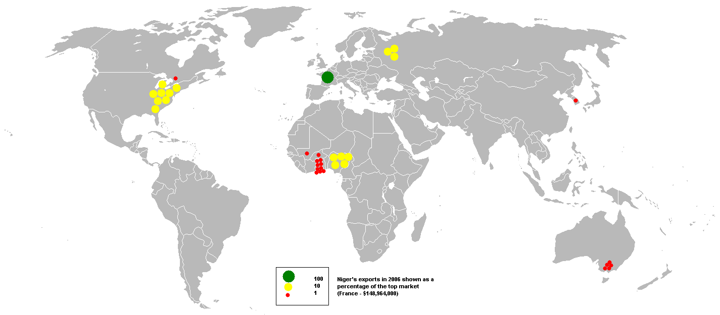
Figure 7: Exports Map of Niger

Source: INS (National Institute of Statistique (INS) et de la Direction Générale des Douanes (DGD) ; Statistics) of Niger

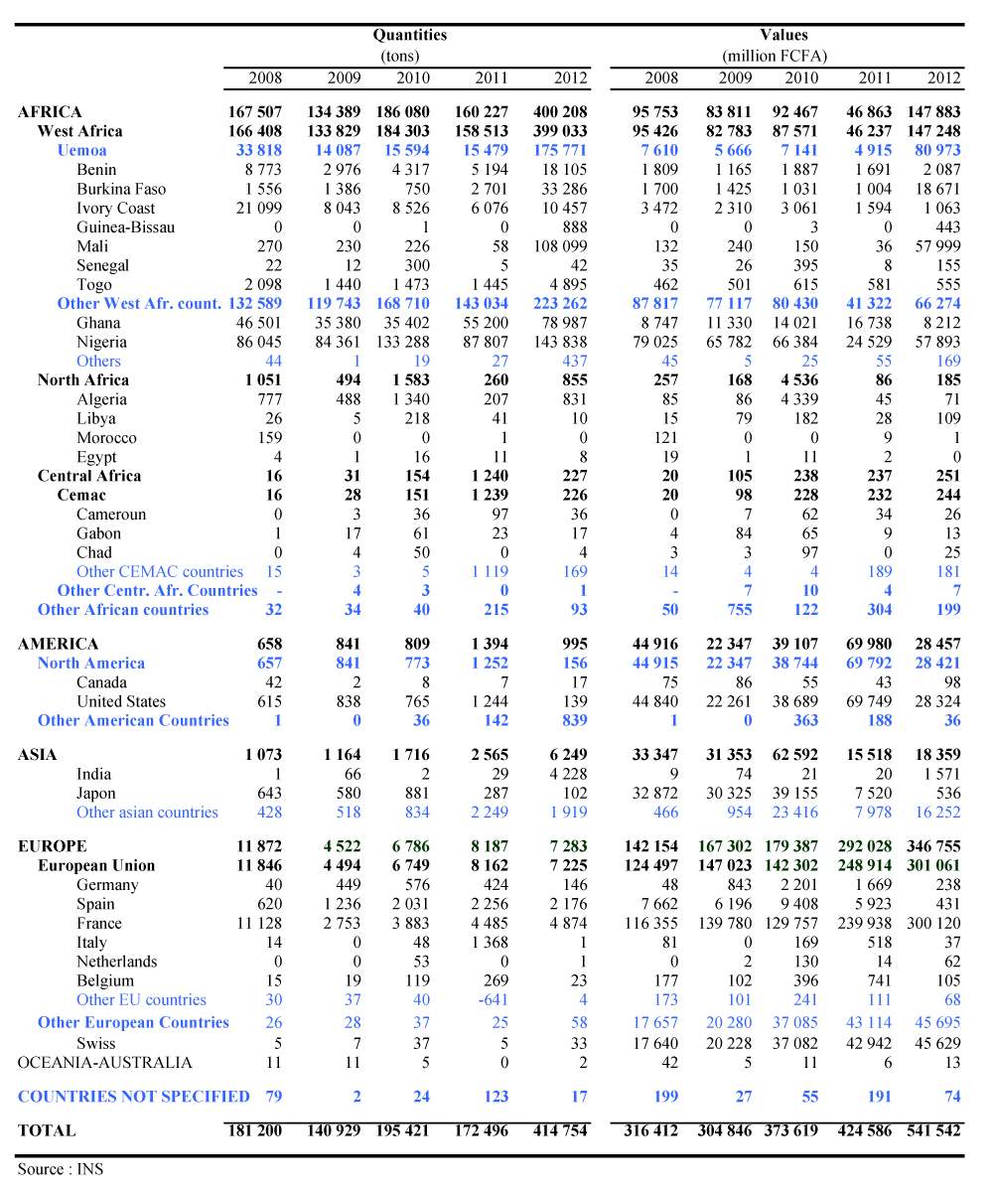
Table 5: Exports by main destination countries
    - Imports
Imports show a preponderance of food purchases, attesting to the country’s lack of food self-sufficiency. The country’s landlocked position results in very high transportation costs, which contribute to deepening the deficit in the balance of payments: in 2005, the latter reached 10.1 per cent of GDP, excluding official transfers, and 7.8 per cent, including these transfers.
Figure 8: Evolution of imports of Niger during the period 2008 - 2012.
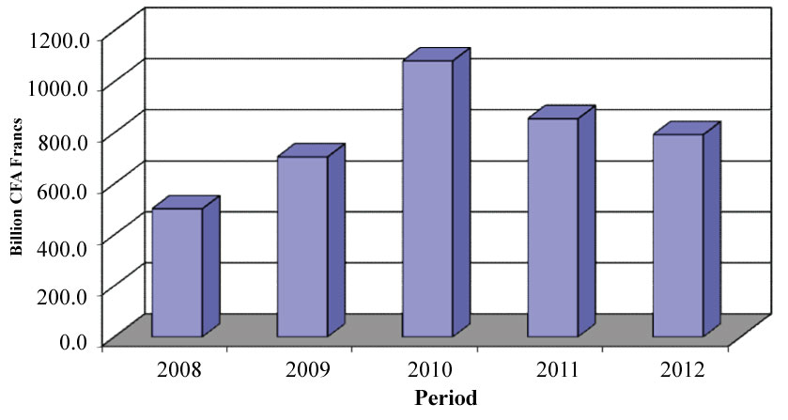
A decrease in imports of 7.3% appears in 2012 (from $ 854.4 billion in 2011 to 792.2 billion in 2012). This decrease, partially offset by the increase observed in particular on rice imports (51.6 billion), freight transport vehicles (+19.4 billion), parts for heavy machinery (+15.4 billion) and fertilizers (+13.9 billion), is mainly induced by hydrocarbons (-131.0 billion). This product which was once the main import product joined in 2012 the group of main export products after extraction of national oil. There spring a rise of 0.7% of imports in the 1st quarter 2013 (215.0 billion against 213.4 billion in the 4th quarter 2012).
- Structure of imports by product
Owing prospecting and operations of mining, the capital goods dominate imports. With 327.6 billion in 2012, they represent 41.4% of the total value of imports. Imports of food products increased by 113.6 billion (by passing from $ 110.1 billion in 2011 to 223.7 billion in 2012). Imports of oil, despite the introduction to the consumption of national oil are 11.1 billion. The problems that marred the production and marketing of this product during the year 2012 may explain what level of imports.

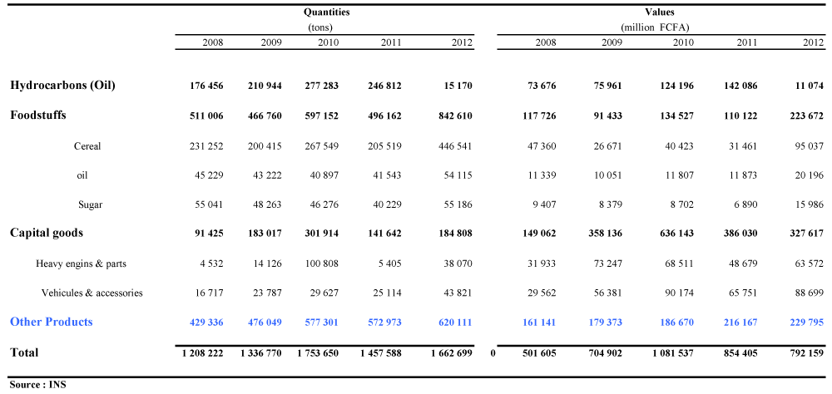
Table 6: Imports by Products Groups

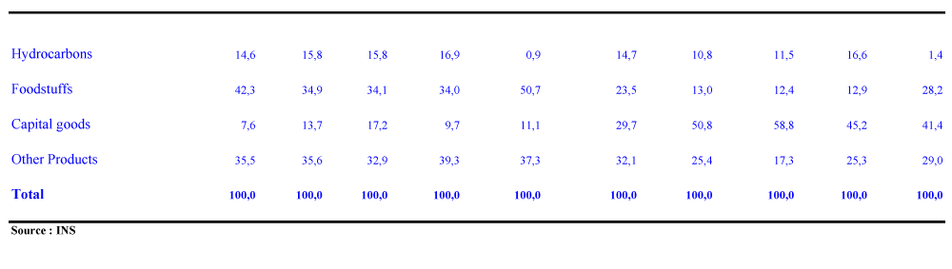
Table 7: Structure of Imports (in percent)

Rice (19.1 billion or 8.9%), freight transport vehicles (10.0 billion or 4.7%), cement (10.3 billion or 4.8%), drugs (7.3 billion or 3.4%) and passenger vehicles (7.9 billion or 3.7%) are the main products of imports during the first quarter of 2013 . Indeed, these five products represent 25.5% of total supply in value over the same period. By groups of products, capital goods with 101.3 billion (47.1%) and food products (46.9 billion or 21.8%) dominate imports in the 1st quarter 2013. They account 68.9% of the total value of imports. These product groups benefit from the down turn of oil imports result of the implementation of national oil consumption.

- Geographical orientation of imports
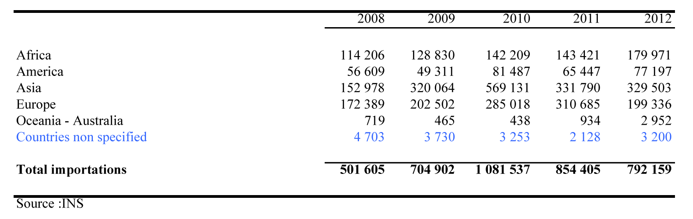
According to the origin, the Asian continent retains the rank of first supplier of Niger. With 329.5 billion, the Asian imports represent 41.6% of the total value of the national supply. Europe, with 199.3 billion (25.2%), ranks second followed by Africa (180.0 billion, or 22.7%).
Table 8: Imports (CIF) by Continent
In the first quarter of 2013, Asia consolidated its position as the leading supplier of Niger. With 108.5 billion, the continent provides 50.5% of total supplies of Niger in value against 51.1% in the previous quarter. Africa with 22.5% (48.3 billion) occupies the second place while his rank was third with 40.2 billion (18.8%) in the 4th quarter 2012. Europe, with 42.0 billion contributes to 19.6% (against 22.8% previously). This makes Europe the 3rd largest supplier of Niger. These three continents contributed to 92.6% (against 92.7% the previous quarter) for domestic supply in the 1st quarter 2013. In annual change, the share of top 3 suppliers in continental level came out at 93.2%.
According to the origin, the main suppliers of Niger are China (174.9 billion or 22.1%), France (100.3 billion or 12.7%). These two countries account for 34.8% of the value of total supply of Niger in 2012. The rank of the first supplier occupied by China is explained by the strong involvement of this country in the mineral exploration and extraction in Niger. In 2011, these two countries, with 27.7% and 12.8% respectively accounted for 40.5% of the total value of the national supply.
In terms of economic unions, the EU leads with 185.6 billion FCFA (23.4%), followed by ECOWAS with 158.0 billion FCFA (20.0%). Imports of WAEMU origin, with 95.2 billion FCFA of purchases, accounted for 12.0% of total acquisitions. Reported to ECOWAS, they represent 60.3%.

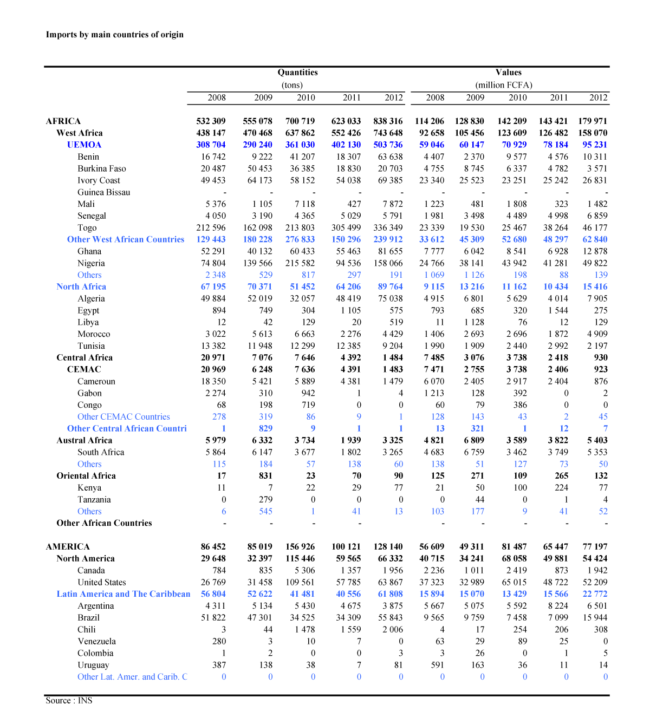
Table 6: Imports by main Countries of Origin

  - Analysis of Balance of Payments
The balance of payments is a statistical statement that records all economic and financial flows between residents of a country and non-residents in a specified period. It is, therefore, an indispensable tool of decision support for authorities. Like the other member countries of the West African Economic and Monetary Union (WAEMU), the Niger’s balance of payments is established annually by the Central Bank of West African States (BCEAO) and validated by the National Committee of the balance of payments. Estimates of this balance are regularly produced on the basis of the information available for the internal needs of the BCEAO and IMF missions.
Let look at the balance of payments of Niger.
Table 7: Evolution of the global balance of the balance of payments (Amounts in millions of FCFA)
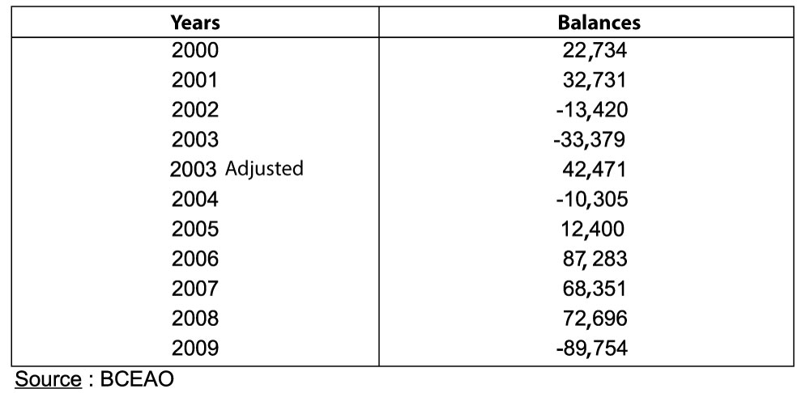

For the third consecutive year, the overall balance of the balance of payments has emerged as surplus, with however a slight decrease compared to 2006. The long-term evolution of the overall balance of the balance of payments of Niger remains highly dependent on internal exogenous shocks which the most recurrent are the agro-climatic conditions, but also external, related to the international environment, that it comes to the rising oil prices on the international market or external financial supports.
Out of trend, balance of 2009 showed a deficit of 89.754 million, in line with the increase of the import bill and declining of external financial support.

Figure 9: Evolution of the global balance of the balance of payments of Niger between 1992 and 2009
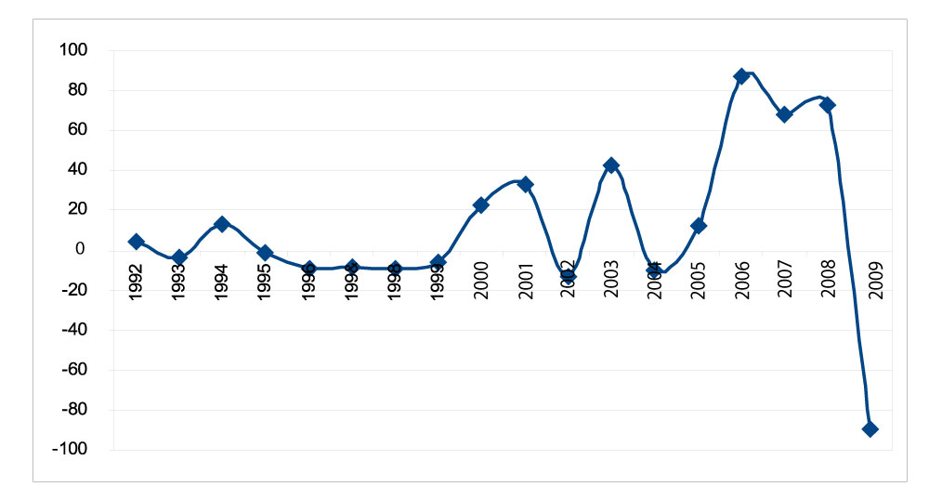
Source: BCEAO
Niger’s trade deficit widened again in 2012, increasing by 25 billion FCFA to 473 billion FCFA, despite the buoyancy of exports, boosted by sales of uranium and the country’s first refined petroleum products. Exports were up 15.0%, representing 22.1% of GDP. Imports, meanwhile, grew by 14.8%, representing 35.8% of GDP. The current account has a structural deficit and deteriorated in 2012. The deficit grew to 795 billion FCFA, or 22.7% of GDP, from 684 billion FCFA in 2011. One of the main causes of this deterioration was the import of capital goods for major extraction investment projects.
Furthermore, food imports almost doubled and imports of other consumer goods also increased. Foreign direct investment (FDI) – mainly Chinese and French investment in the mining and oil sectors – has remained high over the past three years, making the deficits sustainable. Total FDI was 499 billion FCFA in 2011 and 402 billion FCFA in 2012. The current account balance should improve drastically in 2013. Imports of the main refined petroleum products will fall dramatically, while exports should get into their stride after a slow start to 2012. Meanwhile, in early 2012 the IMF approved a new three-year economic programme under the Extended Credit Facility that will further strengthen medium-term macroeconomic stability.
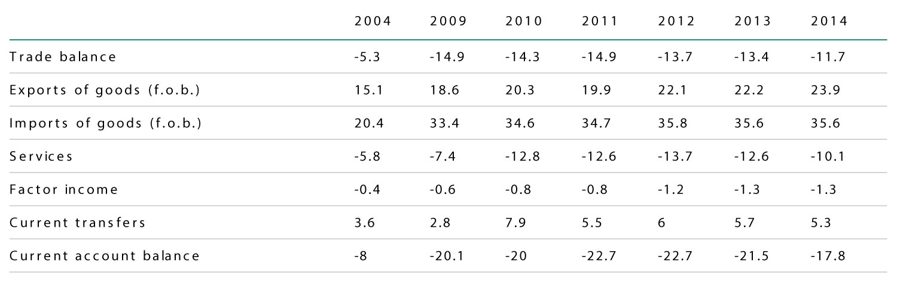
Table 8: Current Account (percentage of GDP)
Source: African Economic Outlook
Figure 10: Comparative evolution of the trade balance and current account between 1992 and 2009
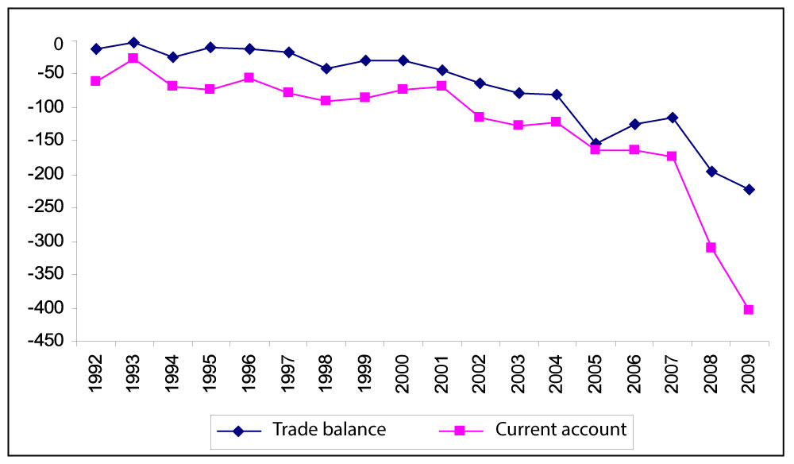
Source: INS
Niger’s trade balance is structurally in deficit, owing not only to the low price and volume of exported products, but also to the import of capital goods, petroleum and food products. The flows associated with imports and linked to the big projects in the oil and uranium sectors have increased tenfold since 2007, attaining 11% of GDP in 20093. Labour and capital income, along with current transfers, are not enough to fill the trade gap, thus resulting in an external current account deficit that has almost tripled, up from 8.2% of GDP to 23.7% between 2007 and 2009. However, the external current account deficit was covered by capital inflows from official development assistance and foreign direct investments (FDI). These flows enabled the country to accumulate exchange reserves equivalent to 2.5 months of import as at end 2009
The balance of payments of Niger showed a debit balance out with credit balances observed since 2005. This reversal results from the degradation of current account, partially offset by the improvement in the capital account and financial transaction. The current account deficit increased from 311,718,000 to 621,322,000 under the effect of a simultaneous deterioration in the balance of goods, services and income well above the improvement of current transfers. This large deficit was financed by an important contribution of public capital and foreign private. In Indeed, the capital account and financial transactions stood at 538.631 million against 390,139,000 in 2008. Overall, the balance of the balance of payments has emerged Deficit 89,754,000 in 2009 against a surplus of 72,696,000 in 2008.

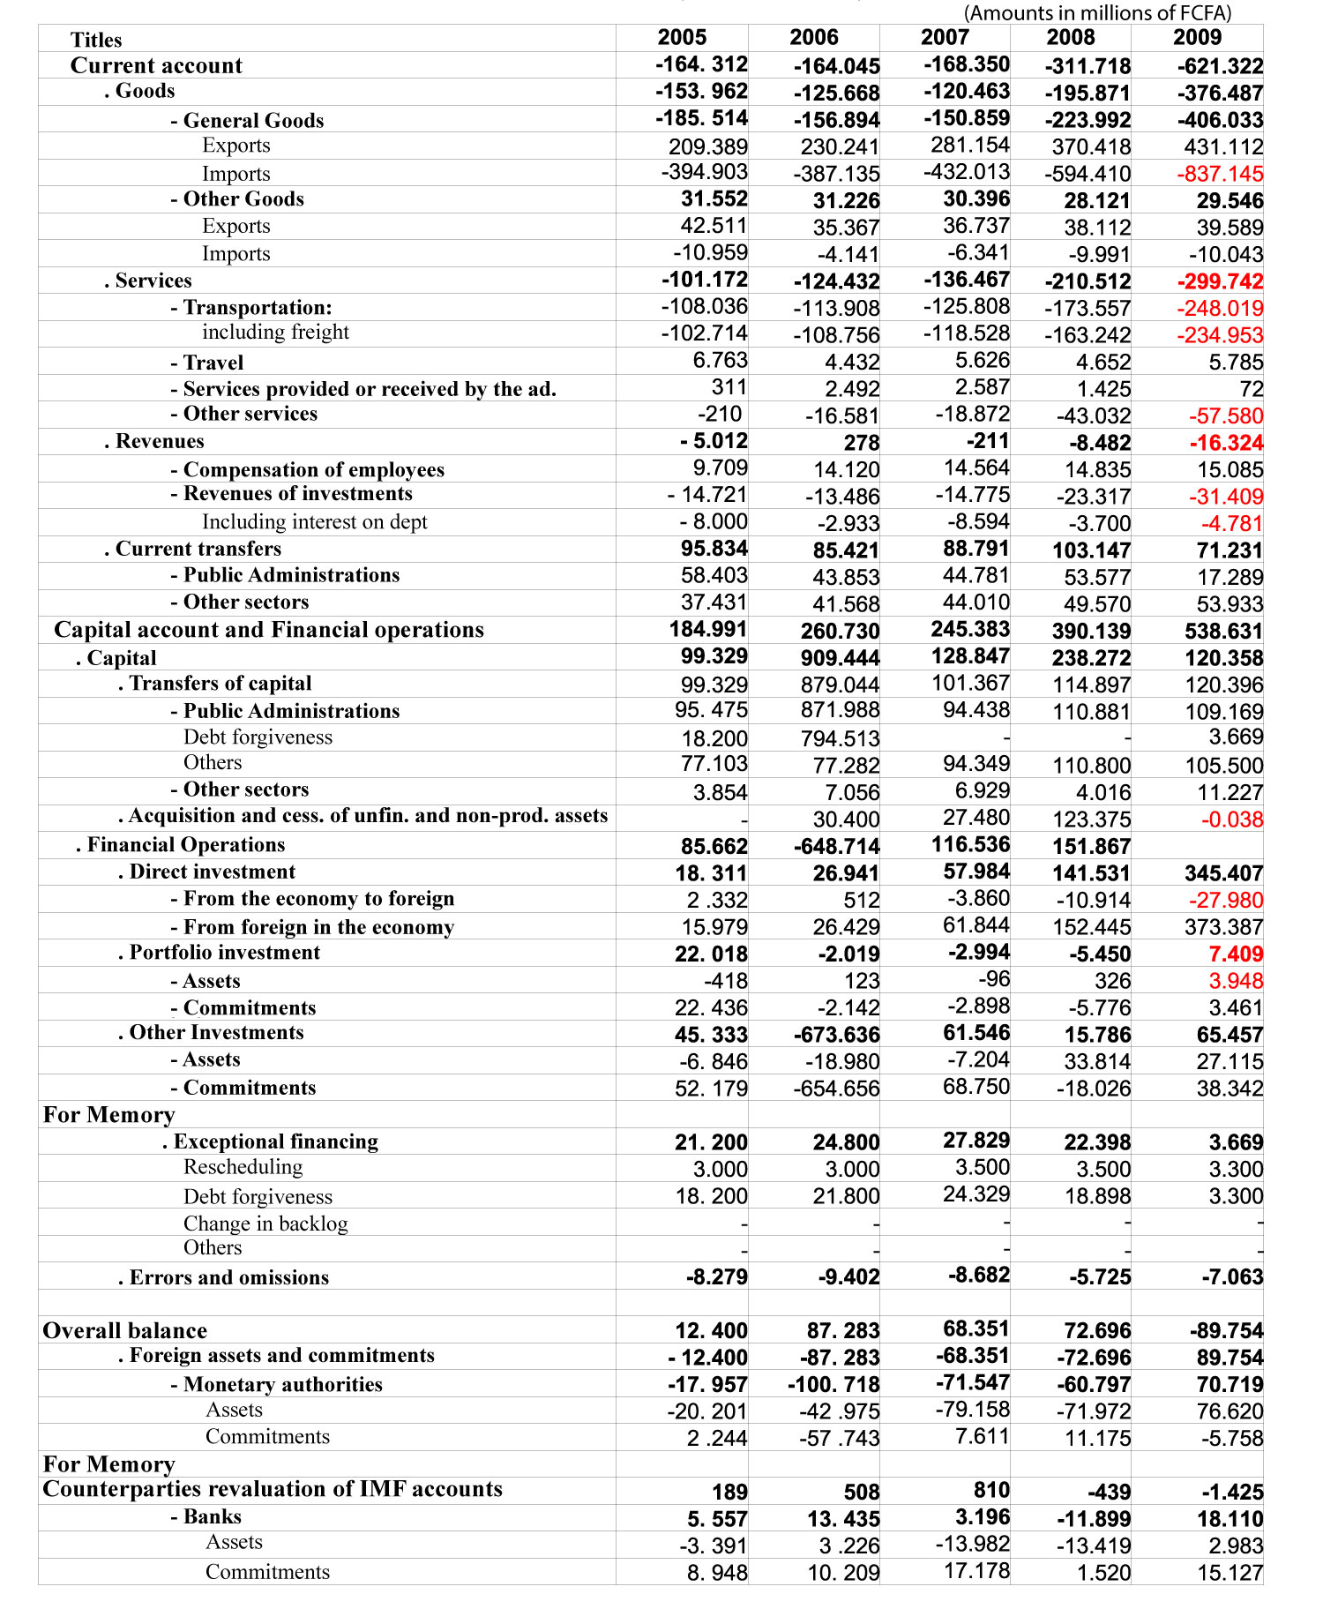
Table 9: Evolution of the balance of payments (optical BCEAO)

- REGIONAL AND BILATERAL RELATIONS
The trade of Niger is officially administrated by the Department of Trade and Private Sector Promotion. But there are also the Nigerien Association of Export Promotion (ANIPEX) and the Chamber of Commerce, Industry and Crafts of Niger (CCIAN) which play a very crucial role in the blossoming of foreign trade in Niger by forging bilateral relationships with regional and international organizations.
  - The position of Niger’s Foreign Trade in Africa
The position of Niger Trade in Africa is more focused in West Africa where it (Niger) is one of the biggest suppliers in mining and Agricultural goods. Despite this Niger remain with a low economic profile in the region. Its big trade partner in West Africa is Nigeria: its neighbour country. In the table below we can see that the external current account of Niger as percentage of GDP is a little bit low compared to that of Western African countries. It is also low compared to that of the whole of Africa.
The trade balance of Niger (-22.7 in 2012) in western Africa is normal compared to other countries but it is low compared to that of the whole of Africa (with -0.4 in 2012). We can observe the same scenarios for the previous years and projections years.
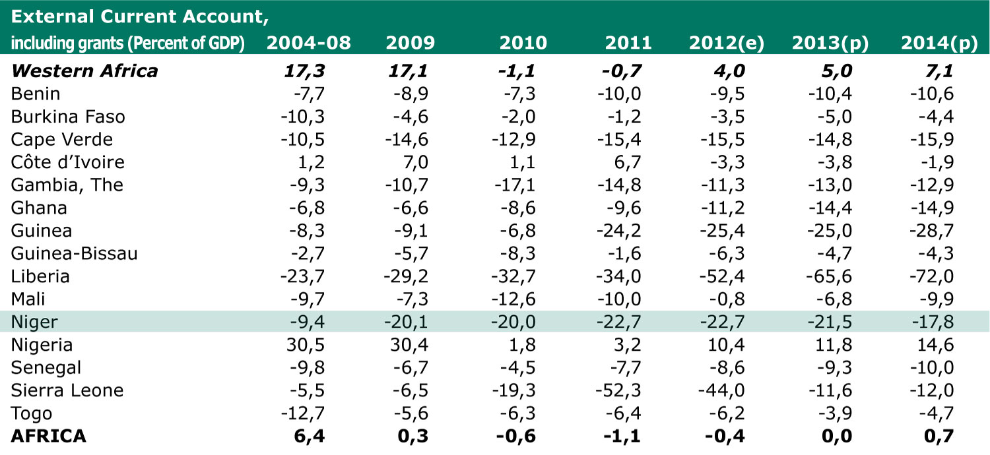
Table: External Current Account (percent of GDP)
e: estimates; p: projections
Source: African Economic Outlook

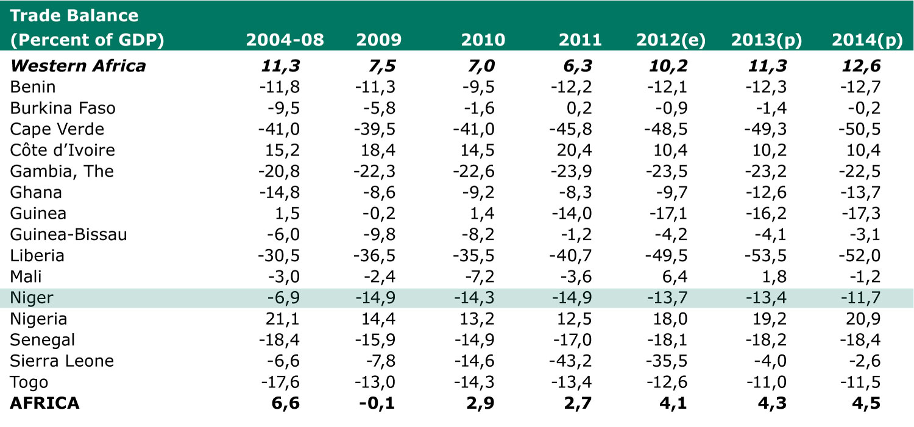
Table: External Current Account and Trade Balance (percent of GDP)
e: estimates; p: projections
Source: African Economic Outlook
  - The position of Niger’s Foreign Trade in the World
During the ten passed years, the Niger’s foreign trade was focused on uranium and capital goods. Today Niger took places in the list of Oil producers in the world and this situation gives to it the opportunities to meet new markets in the world. According to WTO’s data, the Niger trade level is very under the international trade level.
  - The Relationship between Niger and Regional and International (Trade) Organizations
The Ministry of Trade and Private Sector Promotion (or, Ministry of Commerce) is the structure responsible for trade policy adopted by the Government of Niger. The Ministry of Commerce is responsible for international trade negotiations and the implementation of policies relating to foreign trade. The Minister of Commerce represents the State at ministerial meetings of the WTO and for meetings that affect trade, ministerial meetings of UEMOA, the Economic Community of West African States (ECOWAS) and of the ACP-EU partnership.
Ancient contracting party to GATT 1947, the Niger is a member of the WTO since 13 December 1996. It is recognized as "Least Developed Countries (LDCs)" within the WTO. Niger is not a member of any plurilateral agreement, but it could become an observer to the plurilateral WTO Agreement on Government Procurement. It should be noted that the Niger supported the application by the WAEMU Commission to become an observer to the WTO. The WAEMU member States create progressively a common commercial policy, which they project to put in the WTO.
With the visit of Turkish Prime Minister Recep Tayyip Erdoğan, Niger enter in new partnership with new other partner in Asia. Trade relationships between Niger and Turkey start with the participation of Niger’s businessmen to the International Fair of Istanbul in 2012. After the Prime Minister Recep Tayyip Erdoğan’s official visit, the two country signed several economic agreements in general and commercial agreements particularly.
  - Agreements With Regional and International (trade) Organizations
Niger has concluded over the years many bilateral trade agreements and economic cooperation. For the most, agreements with other WTO members provide the regime of MFN. More favourable conditions - free admission - are covered by the agreement with Tunisia. However, bilateral trade agreements of Niger and the other members of WAEMU will gradually be replaced by agreements between UEMOA and third countries.
Niger is a member of the Agreement Establishing the Multilateral Investment Guarantee Agency (MIGA) since June 11, 2002, and the International Centre for Settlement of Investment Disputes (ICSID) since 14 December 1966.
Regarding regional integration, Niger has signed and ratified all protocols and agreements drawn up by the main regional integration and cooperation bodies, including WAEMU and ECOWAS. Niger participates actively in discussions on Economic Partnership Agreements (EPAs) and on introducing a five-band common external tariff (CET) for ECOWAS. The challenge for the customs authorities is to combat fraudulent imports of goods, especially from Benin and across the porous 1 500 km border between Niger and Nigeria.
Niger is one of the ACP countries with which the EU signed the Partnership Agreement. This agreement entered into force on 1 March 2000 and was signed on 23 June 2000 in Cotonou, Benin. It replaces the Lomé Convention, in effect since 1975, the fourth extension expired at the end February 2000.
The trade provisions are one of the mechanisms of cooperation between the ACP countries and the EU. The latter admits as franchises, the industrial products and the processed agricultural products originating in 70 ACP countries on the basis of non-reciprocity (the Agreement on Trade, Development and Cooperation applies to South Africa).
Seeing the structure of trade with the EU, constituted mainly by uranium, Niger benefited primarily from the operation of the STABEX mechanism on peanuts, however small-scale
The principal acts of the WAEMU on Trade in Goods
- The WAEMU Treaty ;
- Additional Act No 4/ 96 of 10 May 1996 establishing a preferential tariff regime for trade within WAEMU , as amended by the Additional Act No 4/ 98;
- Regulation No. 2/97/CM/UEMOA adopting the WAEMU CET ;
- Directive No. 2/98/CM/UEMOA harmonizing the laws of the Member States relating to the Value Added Tax (VAT) ;
- Directive No. 3/98/CM/UEMOA on harmonization of legislation of Member States concerning excise duties ;
- Regulation No. 5/98/CM/UEMOA wearing definition of the list of categories of goods used in the tariff and statistical nomenclature of the WAEMU, as amended;
- Regulation No. 3/99/CM/UEMOA adopting the mechanism of degressive protection tax ( TDP ) in the UEMOA , as amended ;
- Regulation No. 4/99/CM/UEMOA instituting a system of reference value;
- Regulation No. 5/99/CM/UEMOA wearing customs value of goods;
- Protocol No. III/2001 establishing the rules of origin of products WAEMU ;
- Additional Act No. 3/ 2001 on the adoption of the WAEMU Agricultural Policy ;
- Directive No. 06/2001/CM/UEMOA harmonizing the taxation of petroleum products within the WAEMU ;
- Regulation No. 09/2001/CM/UEMOA adopting the Customs Code of the UEMOA (Book I: organizational frameworks , procedures and customs regimes ) ;
- Regulation No. 2/2002/CM/UEMOA on anti-competitive practices within the WAEMU ;
- Regulation No. 3/2002/CM/UEMOA in the applicable agreements and abuse of dominant position within the WAEMU procedures and
- Regulation No. 4/2002/CM/UEMOA on State within WAEMU and aid modalities application of Article 88 ( c) of the Treaty.

Source: www.uemoa.int [27 April 2003]
- CONCLUSION
The Nigerien economy already handicapped by internal structural constraints must cope with the demands of an international economic context characterized by economic globalization and open markets.
Niger's foreign trade is characterized by a chronic deficit in its trade balance. The rate of coverage of imports by exports rarely exceed 50% over the past 50 years of independence. This uncontrolled trade also reflects the primary character of the Nigerien Economy. Indeed, apart from uranium exports mainly concern the products of Livestock derivatives and agricultural products. The predominance of agro products in exports does not mean self-sufficiency in this sector. And this affects directly the balance of payments. According to the data, cereals are the second largest import item after fuel. Food products (cereals, oils and sugars) are on average more than 30% of imports in the last ten years. Vehicles and other equipment and machinery as well as salt and pharmaceuticals are other major import products. Trading partners of Niger are much undiversified largely for exports and relatively less on imports. Only three countries (France, Nigeria and Japan) absorbs on average more than 80% of Niger origins during the last ten years when six countries (France, Côte d'Ivoire, Nigeria, China, USA and Japan) provide Niger to nearly 60% on average over the past ten years.
Despite the several agreements it signed, Niger has a low level in international trade. This is due to the bad economic situation it has lived the last years. But today, as oil producer Niger’s door is open to the new markets with its new economic projections.
- REFERENCES
African Economic Outlook (2013), Niger overall,
African Economic Outlook (2013), West Africa,
http://www.africaneconomicoutlook.org/en/countries/
BCEAO (2009), Balance des Payments et Position Extérieure Globale (Balance of Payments and Overall External Position), Niger;
CCIAN (2000), Examen des politiques Commerciales du Niger (Review of Trade Policies of Niger), bilateral relationships 20-10
CIA The World Factbook (2012), Niger: Economy: https://www.cia.gov/library/publications/the-world-factbook/geos/ng.html
INS: National Institute of Statistics (2010), Annuaire statistique 2006-2010 (Statistical Yearbook 2006-2010), Niger 2010;
INS: National Institute of Statistics (2012), STATISTIQUES DU COMMERCE EXTÉRIEUR 2008 – 2012 (Foreign Trade Statistics 2008-2012), Niger March 2012;
INS: National Institute of Statistics (2013), STATISTIQUES DU COMMERCE EXTERIEUR PREMIER TRIMESTRES 2013 (Foreign Trade Statistics first Quarter 2013), Niger June 2013;
http://www.stat-niger.org/statistique/
Wikipedia (2013) Economy of Niger: http://en.wikipedia.org/wiki/Economy_of_Niger, December 2013

Throughout this table, the dot (.) Is used as a thousands separator.

